
Diffraction

Objective of this module is to provide students with a comprehensive understanding of diffraction. Through theoretical explanations, simulations, and practical examples, students will develop a clear grasp of diffraction and its significance in various fields of science and technology, with a particular focus on electron diffraction.

Activity with the interface
https://qtechedu.centralesupelec.fr/EN/ex6.html

In this module, we study diffraction through a single slit for both light and matter particles. We explore how the diffraction pattern arises in each case, emphasizing the wave-like behavior described by classical optics and quantum mechanics.
1. To analyze the diffraction of light through a single slit, use the "Visualizer" provided in this section. You can control the wavelength of the incident light using the “Wavelength” slider and adjust the aperture (slit width) using the “Aperture” slider. The positions of the diffraction minima relative to the central maximum are displayed to aid your analysis. The screen width is 1.25 meters, and the distance between the slit and the screen is 1 meter.

- Give a general definition of diffraction and provide examples.
- State the formulation of the Huygens-Fresnel principle. Explain how the Huygens-Fresnel principle leads to the diffraction pattern observed at a single slit.
- Using the dynamic figure in the interface with the sliders, change:
- The width of the slit while keeping the wavelength constant.
- The wavelength of the light while keeping the slit width constant.
Describe your observations and explain what conclusions you can draw.
- Quantify how the width of the central maximum changes with slit width and wavelength.
- Determine the position of the first diffraction minimum for a wavelength of 400 nm and a slit width of 0.3 µm. Explain the physical meaning of this position in the diffraction pattern.
- Describe how changing experimental parameters affects the number and visibility of maxima and minima.
- Determine the maximum number of maxima and minima that can be observed under the given conditions.
2. In the second section, “Modeling Wave Packet Propagation Through a 1D Slit Structure,” the diffraction of particles through a single slit is analyzed. To modify the potential profile and wave packet parameters, use the corresponding input fields in the interface. Click the “Update Profile” button to apply the changes. To restore the default configuration, use the “Reset to Default” button. You can also change the calculation parameters, such as the number of points for time discretization, the time step, or the position of the screen.
Once all parameters are defined, run the simulation using the “Run Simulation” button to observe how the wave packet interacts with the slit structure.
Note: Atomic units are used in this module *.

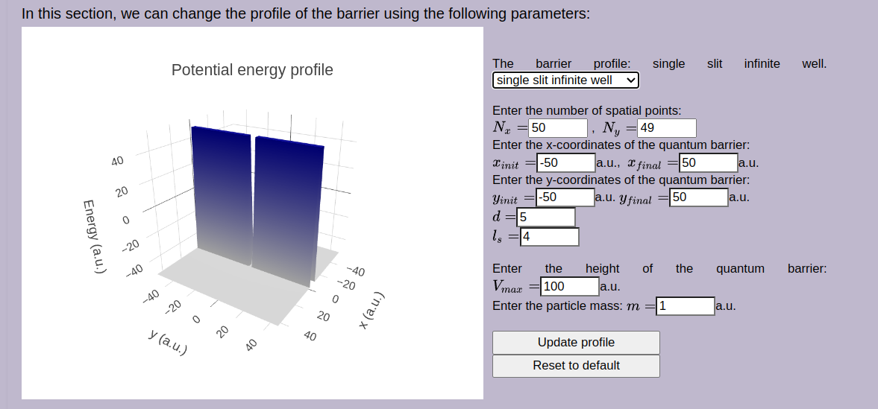 | Use the interface to define the parameters used to determine the barrier:  N_{x}, N_{y}:  x_{init}, x_{final}:  y_{init}, y_{final}:  d:  l_{s}:  V_{max}:  m:
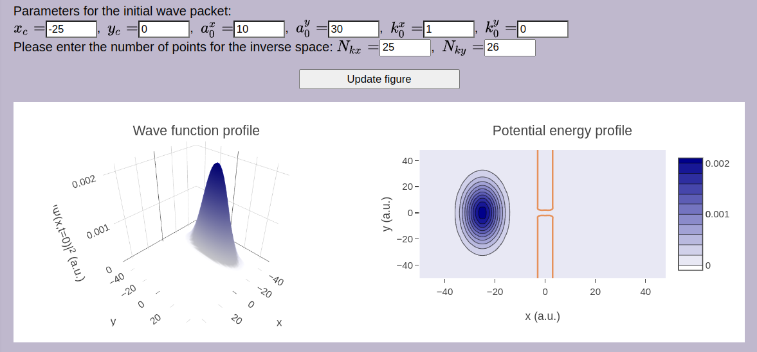 | Give definitions of the parameters for the initial wave packet:  x_{c}:  y_{c}:  a₀^{x}:  a₀^{y}:  k₀^{x}:  k₀^{y}:

1) Identify and describe the physical quantities shown in the figures. Then, discuss the main features of each graph.
2) What is a wave packet? Why is it used in quantum mechanical calculations, particularly in the study of diffraction of particles like electrons?
3) In the simulation of particle diffraction through a one-dimensional slit structure, various numerical methods can be used, including the Chebyshev expansion method. Briefly explain what the Chebyshev method entails. What is a propagator in this context? Additionally, list and briefly describe other special functions commonly used in quantum mechanical calculations.
4) Investigate (using the interface) how the geometry of the slit (width, height of the barrier etc.) affects:
- the spreading (dispersion) of the wave packet ;
- its transmission through the barrier;
- discuss how these geometrical parameters influence the resulting diffraction pattern, particularly in terms of the central peak width and the presence and structure of side lobes.
5) Study the influence of the wave packet parameters on the resulting diffraction pattern:
- Its position relative to the slit - change the initial position parameters x₀ and y₀;
- Its spatial localization - adjust the initial spread of the wave packet;
- Its velocity - modify the momentum components.
6) Using the interface, determine how changing the velocity of a wave packet affects its spatial characteristics, such as its spread. Perform the simulation for a free particle (no potential barrier). Determine the time when the wave packet will reach the top of the computing field. Verify your calculation using the interface.
Note: Atomic units are used in this module *.
7) Compare qualitatively the diffraction patterns of light and electrons (using the default parameters in the simulation). What determines the intensity of the diffraction maxima in each case?
8) How does diffraction limit the resolution of optical instruments?

* Atomic units https://en.wikipedia.org/wiki/Hartree_atomic_units are used:

the unit of charge is e = 1 (1.602176634×10⁻¹⁹C);
the unit of mass m_{e} = 1 is defined as the mass of the electron (9.1093837139(28)×10⁻³¹ kg);
the unit of action = 1 - reduced Planck constant (1.054571817...×10⁻³⁴ J⋅s);
the unit of length a₀ = 1 - Bohr radius (= 0.529×10⁻¹⁰m);
the unit of energy E_{H} = 1 - Hartree energy (= 4.359×10⁻¹⁸ J = 27.211 eV).

